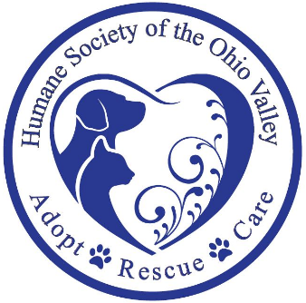

90 Mount Tom Road, Marietta OH 45750
Phone: (740) 373-5959
board@hsov.org
www.hsov.org

HSOV MISSION: Humane Society of the Ohio Valley exists to promote the welfare of domestic animals in Washington County, Ohio. We provide a safe haven shelter for stray, lost and /or abused animals, educate our communities on humane care for these animals, the need for population control, and the relief of suffering for them. We investigate and prosecute complaints of animal abuse and neglect as permitted by the Ohio Revised Code and provide for adoption of our animals by people who can demonstrate that they will provide care consistent with our mission.
MEMBERSHIP FORM

Name _____________________________________________ Date ___________________

Address ____________________________________________________________________

Phone ( ) __________________________ Email _______________________________

Membership fee: $20 for general membership; $500 for lifetime membership.
Additional support: $100 for cat cage sponsor; $300 for dog kennel sponsor
Enclosed is my donation of $______________ which will go toward veterinary bills, food and vaccines.
Please include payment with this form. Checks should be issued to the Humane Society of the Ohio Valley, 90 Mount Tom Road, Marietta, OH 45750; or register on our website, www.hsov.org.
Registrations received by Sept. 1, 2023, qualify for membership in 2023, are eligible to vote to elect directors at our 2023 annual meeting, and may run for election to the board of directors at this meeting. Applications received after September 14, 2023, qualify for membership, attendance at the annual meeting, and to run for the board of directors in 2024.

Signature _______________________________________
Date _________________
HSOV respects your privacy and does not sell or share your information.

